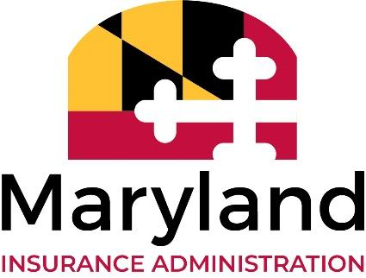
KATHLEEN A. BIRRANE
Commissioner

GREGORY M. DERWART
Deputy Commissioner

LARRY HOGAN
Governor

BOYD K. RUTHERFORD
Lt. Governor

200 St. Paul Place, Suite 2700, Baltimore, Maryland 21202
Direct Dial: 410-468-2000 Fax: 410-468-2020
www.insurance.maryland.gov

NETWORK ADEQUACY WORKGROUP
VIRTUAL MEETINGS NOTICE

The next public meeting to discuss potential revisions to the network adequacy regulations under COMAR 31.10.44 will be held virtually:

May 28, 2021
10:00 A.M. to 1:00 P.M.
Zoom Webinar video conference: https://www.zoomgov.com/j/1606862802
Dial-in number: (833) 568-8864 (Toll Free)
Webinar ID: 160 686 2802
(Please see below for speaker registration information.)

June 18, 2021
10:00 A.M. to 1:00 P.M.
Zoom Webinar video conference: https://www.zoomgov.com/j/1603379277
Dial-in number: (833) 568-8864 (Toll Free)
Webinar ID: 160 337 9277
(Please see below for speaker registration information.)

AGENDAS WILL BE RELEASED PRIOR TO MEETINGS

If you would like to present or offer public comments during the virtual meetings, please notify the MIA in advance by submitting your request to david.cooney@maryland.gov.

To the extent that time and technology permit, the MIA will hear from unregistered participants who access the Zoom Webinar platform.

